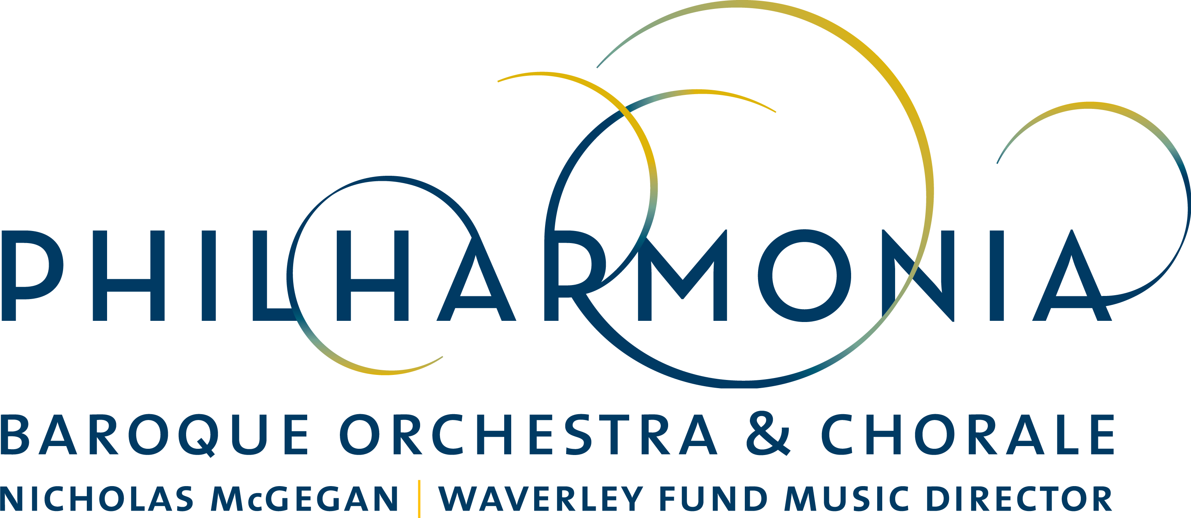

PRESS RELEASE

FOR IMMEDIATE RELEASE

GRAMMY® Nominated Cellist Steven Isserlis Joins PBO for February Concerts

CONTACT:
Dianne Provenzano
Marketing & Communications Director
press@philharmonia.org
(415) 252-1288 x 315

SAN FRANCISCO - BERKELEY - PALO ALTO

December 28, 2017, San Francisco–Philharmonia Baroque Orchestra & Chorale’s
planets have aligned to bring star violoncellist Steven Isserlis back to perform Haydn’s Concerto for Violoncello No. 2 in D major, fresh off his 2018 GRAMMY®-nominated album, in a program featuring Haydn, Mozart and composer-come-astronomer Sir William Herschel called “Harmonic Convergence.”

In addition to a 2017 GRAMMY® nomination for his recording of cello concertos by Haydn and CPE Bach with Deutsche Kammerphilharmonie Bremen, Isserlis’s recording was named “Limelight” Magazine’s Orchestral Recording of the Year for 2017.

In an interview with Australia’s “Limelight” Magazine, Isserlis says, “The D Major is much more operatic. When I checked it out I was not surprised that it was from the year he [Haydn] wrote his last opera. It’s very much about melodies, but it’s also a dramatic thing. It’s so like a love song.”

Considered one of the most important cellists of his generation, Isserlis brings extraordinary verve and a deep complexity to his playing. This marks Isserlis’ fourth appearance with Philharmonia. In addition to the Orchestra’s subscription concerts, Isserlis will also appear with Nicholas McGegan, scholar Francesco Spagnolo and the orchestra in “Jewish Songlines” as part of PBO SESSIONS, the organization’s alternative concert series. This program will take place at the Contemporary Jewish Museum on February 8 at 8 pm.

While Isserlis is the star of the concert series, Nicolas McGegan and the Orchestra will guide our gaze to Haydn at his zenith with his “Mercury” Symphony followed by Mozart’s Symphony No. 17 in G Major and the Symphony No. 8 in C minor by Sir William Herschel who later went on to discover the planet Uranus.

Music scholar John Prescott will present the preconcert talk 45 minutes prior to each of four concerts that will take place throughout the Bay Area. See PBO in “Harmonic Convergence” with Steven Isserlis Wednesday, February 7 at 7:30 pm at First United Methodist Church in Palo Alto; Friday, February 9 at 8 pm at Herbst Theatre in San Francisco; Saturday, February 10 at 8 pm and Sunday, February 11 at 4 pm at First Congregational Church in Berkeley. PBO SESSIONS: Jewish Songlines is on February 8 at 8 pm at the Contemporary Jewish Museum in San Francisco.

Tickets range from $25 to $125. For more information about these and other Philharmonia Baroque Orchestra & Chorale concerts, visit philharmonia.org. For tickets, visit cityboxoffice.com or call 415-392-4400. PBO SESSIONS tickets are available only through PBO Patron Services which can be reached at 415-295-1900.

Classical KDFC is the radio home of Philharmonia Baroque Orchestra & Chorale. KDFC broadcasts an unreleased live Philharmonia concert recording the second Sunday of every month from 8-9 PM.

CALENDAR DETAILS

WHO:
Nicholas McGegan, conductor
Steven Isserlis, violoncello
Philharmonia Baroque Orchestra & Chorale (Chorale not performing)

WHAT: Concert Performance
Harmonic Convergence with Steven Isserlis

PROGRAM:
MOZART Symphony No. 17 in G major
HAYDN Concerto for Violoncello No. 2 in D major
HERSCHEL Symphony No. 8 in C minor
HAYDN Symphony No. 43 in E-flat major “Mercury”

PRICE: Range from $28 to $125

TICKETS: Available at City Box Office 415-392-4400 or cityboxoffice.com

WHEN/WHERE:

Wednesday February 7, 7:30 pm
First United Methodist Church, Palo Alto

Friday February 9, 8 pm
Herbst Theatre, San Francisco

Saturday February 10, 8 pm
First Congregational Church, Berkeley

Sunday February 11, 4 pm
First Congregational Church, Berkeley

_________________________________________________________________

ABOUT PHILHARMONIA BAROQUE ORCHESTRA & CHORALE

Under the musical direction of Nicholas McGegan for over 32 years, Philharmonia Baroque Orchestra & Chorale (PBO) is recognized as America’s leading historically-informed ensemble. Using authentic instruments and stylistic conventions of the Baroque to early-Romantic periods, the Orchestra engages audiences throughperformance, tours, recordings, commissions, and education of the highest standard. Founded in the Bay Area 37 years ago, the ensemble is the largest of its kind in the United States.

PBO’s musicians are among the best in the country and serve on the faculties of Juilliard and Harvard, among others. The Orchestra performs an annual subscription season in four venues throughout the Bay Area and has its own professional chorus, the Philharmonia Chorale. It welcomes eminent guest artists such as mezzo-soprano Susan Graham, countertenor David Daniels, mezzo-soprano Anne-Sofie von Otter, fortepianist Kristian Bezuidenhout, and maestro Richard Egarr. The Orchestra enjoys numerous collaborations, including a regular partnership with the Mark Morris Dance Group, and appears regularly at Carnegie Hall, Lincoln Center, Walt Disney Concert Hall, Tanglewood, Weill Hall at the Green Music Center, and Bing Concert Hall at Stanford University.

In April 2017, PBO performed the modern-day premiere of Rameau’s “Le Temple de la Gloire”, its first fully-staged opera in collaboration with Cal Performances, Centre de Musique de Versailles, and the New York Baroque Dance Company. The production received critical acclolades from around the world.

Among the most recorded orchestras in the world, PBO boasts a discography of over 40 recordings and launched its own label on which it has re-leased nine recordings, including a coveted archival performance of mezzo-soprano Lorraine Hunt Lieberson singing Berlioz’s “Les nuits d’été,” and received a GRAMMY® nomination for a recording of Haydn symphonies. The Orchestra will release in spring 2018, Jean-Phillipe Rameau’s Le Tample de la Gloire, its 10th recording on the Philharmonia Baroque Productions label,

PBO also commissions new works regularly, including a one-act opera “To Hell and Back," by acclaimed composer Jake Heggie, “Red, Red Rose” by Pulitzer Prize-winning composer Caroline Shaw, which enjoyed its world premiere at Walt Disney Concert Hall in May 2016, a second commission by Shaw in 2017 and two more on the way.

The Orchestra can be heard regularly on the Bay Area’s Classical KDFC. PBO maintains a suite of highly-regarded education programs, including its partnership with the Juilliard School’s Historical Performance program.

