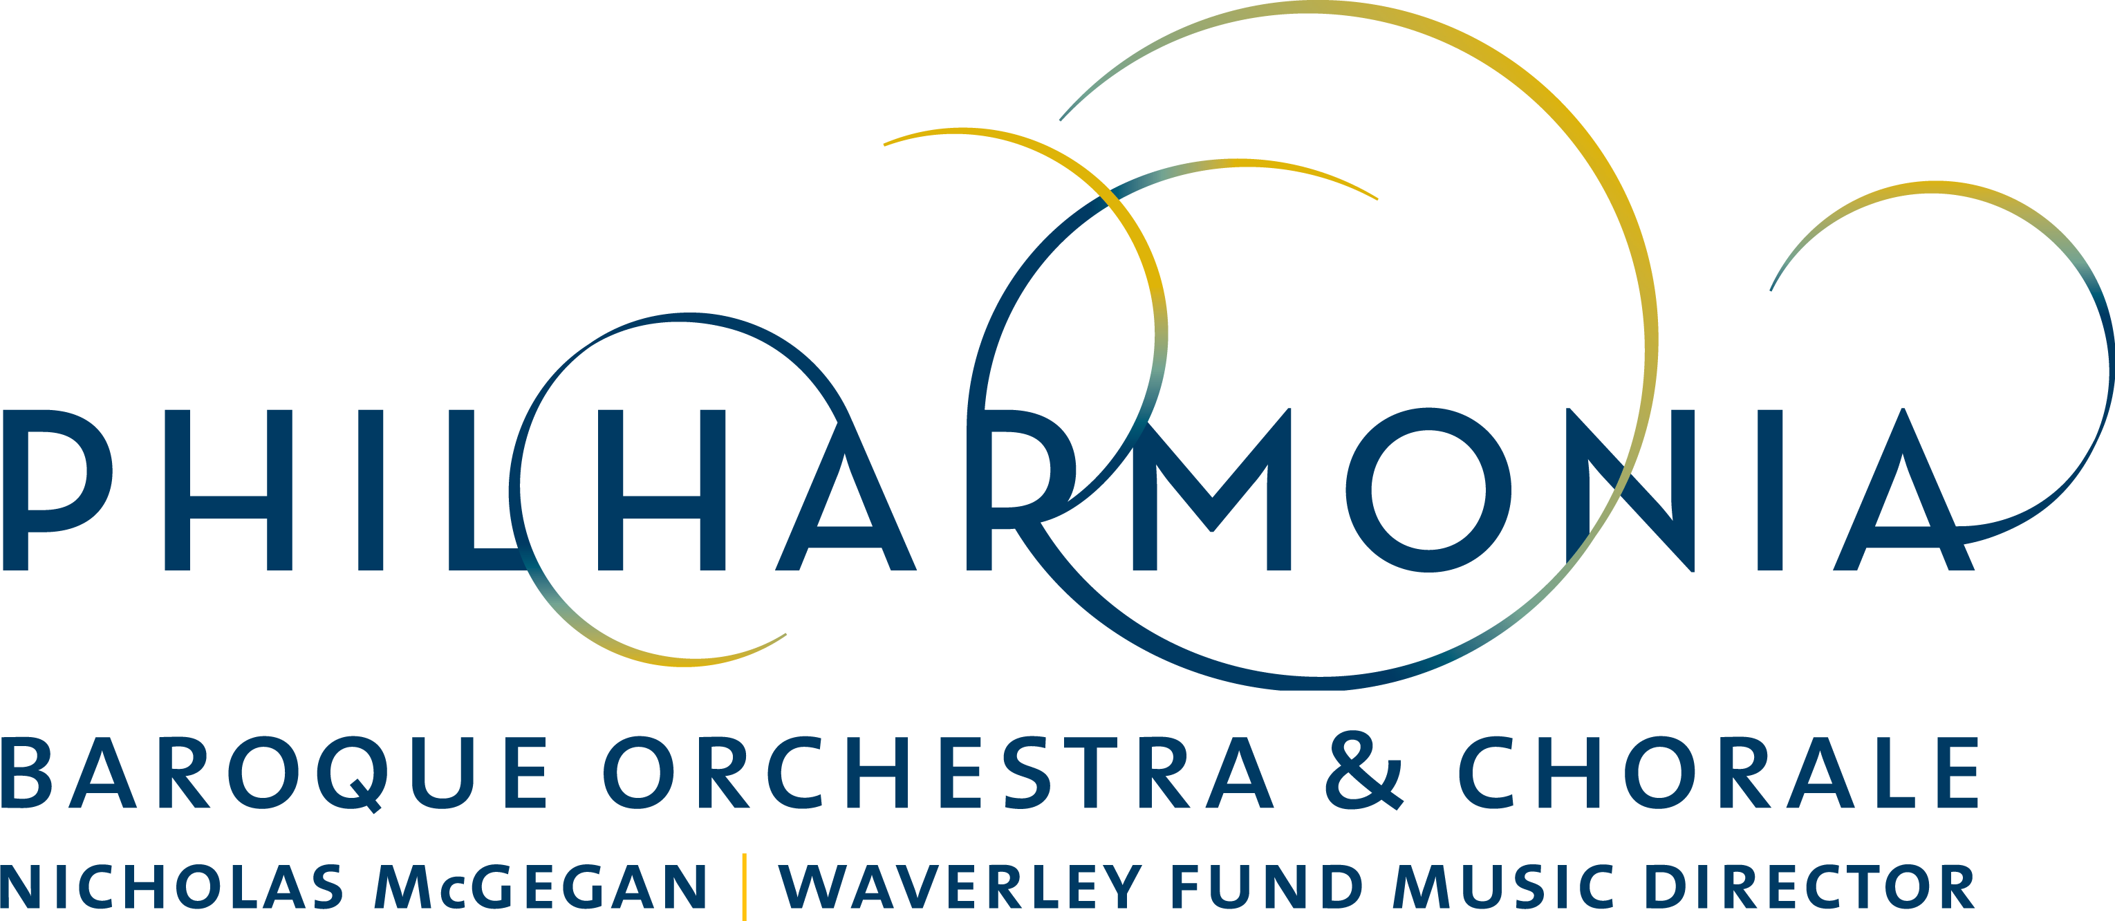

PRESS RELEASE

FOR IMMEDIATE RELEASE

PBO Closes Season with Impassioned Beethoven Program Spotlighting Chorale and Star Soloist Debuts

CONTACT:
Dianne Provenzano
Marketing & Communications Director
press@philharmonia.org
(415) 252-1288 x 315

SAN FRANCISCO - BERKELEY - PALO ALTO

March 19, 2018

SAN FRANCISCO–Waverley Fund Music Director Nicholas McGegan and Philharmonia Baroque Orchestra & Chorale are soon to cap off another season of historically informed performances with a powerful Beethoven program that includes the composer’s monumental Mass in C major, Op. 86 and Fantasia in C minor, Op. 80 “Choral Fantasy” in concerts throughout the Bay Area April 25–29.

The 2017/18 season finale entitled “Beethoven Unleashed” is inspired by Beethoven’s epic Akademie concert of 1808, during which he premiered the Mass in C and “Choral Fantasy.” PBO will also include Cherubini’s poignant tribute to Haydn, “Chant sur la mort de Joseph Haydn.”

These performances mark the Bay Area introduction of contralto Avery Amereau, “an extraordinary America alto on the rise” (The New York Times) and fresh off her second Metropolitan Opera appearance as Kate Pinkerton in Puccini's “Madame Butterfly.” She will be making her PBO debut alongside Bay Area baritone Hadleigh Adams, who recently gave a critically acclaimed performance at New York’s White Box as Zoroastro in a modern production of Handel's “Orlando.” French soprano Chantal Santon-Jeffery will make her return to PBO after her performance last April as “Glory” in PBO's fully staged Rameau opera “Le Temple de la Gloire.” Virtuosic tenors Thomas Cooley and David Kurtenbach, soprano Helene Zindarsian, and Bay Area fortepianist Eric Zivian add to the line-up of talented soloists for these highly anticipated performances.

Prominently featured in this program are the powerful voices of the Philharmonia Chorale, led by PBO Chorale Director and Scholar-in-Residence Bruce Lamott. About this program, Lamott says, “Despite his deafness, Beethoven sensed the thrilling response that his choral music would spark in his audience. Whether it was the rapturous expression of the sublime, the profound depths of sorrow, or the simple sentiments common to all of his listeners, he brought instruments and voices together to speak to the hearts of everyone in his audience.”

PBO’s season finale “Beethoven Unleashed” takes place on Wednesday, April 25 at 7:30 p.m. at Bing Concert Hall, Stanford; Friday, April 27 at 8 p.m. at Herbst Theatre, San Francisco; and on Saturday, April 28 at 8 p.m. and Sunday, April 29 at 4 p.m. at First Congregational Church in Berkeley. There will be a pre-concert talk given by Philharmonia Chorale Director and Scholar-in-Residence Bruce Lamott forty-five minutes prior to each performance that will be open to all ticket-holders.

Tickets range from $28 to $125 at the Berkeley and San Francisco venues only and are available through City Box Office at cityboxoffice.com or 415-392-4400. Tickets for the Bing Concert Hall performance only range in price from $15 to $95 and are available at stanfordlive.org and 650-724-BING (2464). (Due to strong presales for this concert dynamic pricing may take effect.)

For more information about this program and Philharmonia Baroque Orchestra & Chorale’s upcoming 2018/19 season, please visit philharmonia.org.

Classical KDFC is the radio home of Philharmonia Baroque Orchestra & Chorale. KDFC broadcasts an unreleased live Philharmonia concert recording the second Sunday of every month from 8-9 PM.

CALENDAR DETAILS

WHO:
Nicholas McGegan, conductor
Philharmonia Baroque Orchestra & Chorale

WHAT: Concert Performance
Beethoven Unleashed

PROGRAM:
BEETHOVEN Mass in C major, Op. 86
CHERUBINI “Chant sur la mort de Joseph Haydn”
BEETHOVEN Fantasia in C minor, Op. 80 “Choral Fantasy”

FEATURED ARTISTS:
Nicholas McGegan, conductor
Chantal Santon-Jeffery, soprano
Helene Zindarsian, soprano
Avery Amereau, contralto
Thomas Cooley, tenor
David Kurtenbach, tenor
Hadleigh Adams, baritone
Eric Zivian, fortepiano
Philharmonia Chorale, Bruce Lamott, director

TICKETS: (Note different pricing per venues)

San Francisco and Berkeley $28-$125
Available at City Box Office 415-392-4400 or cityboxoffice.com

Bing Concert Hall $15-$95
Available at Stanford Live 650-724-BING (2464) or stanfordlive.org

WHEN/WHERE:

Wednesday April 25, 2018 at 7:30 p.m.
Bing Concert Hall, Stanford

Friday April 27, 2018 at 8:00 p.m.
Herbst Theatre, San Francisco

Saturday April 28, 2018 at 8 p.m.
First Congregational Church, Berkeley

Sunday April 29, 2018 at 4 p.m.
First Congregational Church, Berkeley

