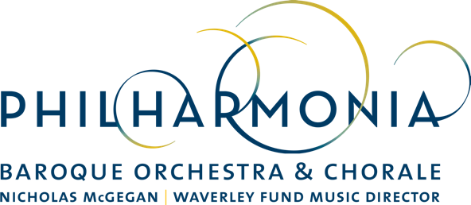

PRESS RELEASE

FOR IMMEDIATE RELEASE

CONTACT:
Dianne Provenzano
Marketing & Communications Director
(415) 252-1288 x 315
press@philharmonia.org

PBO SESSIONS Presents Richard Egarr in Program Exploring the Musical Influence of Composer Arcangelo Corelli

February 7, 2018, San Francisco––Philharmonia Baroque Orchestra & Chorale presents the next installment in the PBO Sessions series: “Corelli the Godfather: The Corleone of the Concerto.” The evening will be led by the Academy of Ancient Music’s Director Richard Egarr and takes place on Wednesday, March 7 at 8 pm at ODC Theater in San Francisco.

PBO’s popular PBO Sessions alternative concert series has matured into its fourth season as an alternative to standard classical concerts. With its own ever-growing audience, the PBO Sessions format allows conductors, scholars and musicians the opportunity to take audiences on a guided and deconstructed tour of music, social and political history, and art. The 90-minute program includes multimedia and intimate dialogue from the stage in addition to live performances of orchestral and vocal music.

This 3rd and final PBO Sessions program of the 2017/18 season will explore the history of the concerto and how it has become one of the most important compositional techniques still used today. In a musical culture preoccupied with opera at the time, Corelli became the paragon—if not the godfather—of the Italianate style in instrumental music. And his influence spread far and wide. The program includes works by Corelli and Handel with a few musical surprises. Afterwards, audience members are invited to stay for complimentary wine and a chance to meet the performers.

General admission tickets are just $25 and concerts typically sell out.

“PBO SESSIONS Corelli the Godfather: The Corleone of the Concerto” is sponsored by The Waverley Fund and Goodby, Silverstein & Partners.

CALENDAR EDITORS, PLEASE NOTE:

WHO:
Richard Egarr, conductor and speaker
Members of Philharmonia Baroque Orchestra & Chorale

WHEN/WHERE
Wednesday, March 7 @ 8 p.m.
ODC Theater
3153 17th St, San Francisco

TICKETS
General Admission - $25
Available online at philharmonia.org/pbo-sessions

