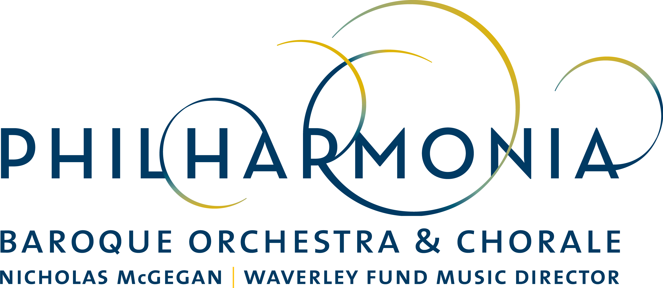

PRESS RELEASE

FOR IMMEDIATE RELEASE

Academy of Ancient Music’s Director Richard Egarr Returns to Lead PBO in March Jam Sessions

CONTACT:
Dianne Provenzano
Marketing & Communications Director
press@philharmonia.org
(415) 252-1288 x 315

SAN FRANCISCO - BERKELEY - PALO ALTO

January 31, 2018, San Francisco–Acclaimed scholar, conductor and virtuoso keyboardist Richard Egarr from the UK’s Academy of Ancient Music joins forces with Philharmonia Baroque Orchestra & Chorale in March to lead the Orchestra through a self-conceived program of concerti grossi by composers Handel and Corelli, while adding his own virtuosic flair on the organ.

This marks Egarr’s 3rd appearance with PBO and he has become a crowd-pleasing favorite of the PBO audience. A renowned keyboard prodigy, Egarr is also acclaimed for his high energy and inventiveness as a conductor. Music Director of the Academy of Ancient Music since 2006, Egarr was recently appointed Principal Guest Conductor of the Residentie Orkest in The Hague from 2019, and was Associate Artist of the Scottish Chamber Orchestra 2011-2017. He has conducted major symphonic orchestras such as London Symphony, Royal Concertgebouw and Philadelphia Orchestra, has frequently guested with leading baroque ensembles such as Tafelmusik and appears regularly at Carnegie Hall, The Kennedy Center and elsewhere. He is on the faculty of The Juilliard School’s Historical Performance Program and frequently serves as guest conductor of Juilliard415, the school's period instrument ensemble.

PBO’s March program, titled by Egarr, “Corelli the Godfather” has Egarr leading from the organ in a program featuring mostly concerti grossi with PBO musicians taking turns in the spotlight. Egarr will illuminate the influence that Corelli had one Handel who studied and stole from Corelli over his lifetime. Egarr also takes the opportunity to shine as he performs Handel’s Organ Concerto No. 15 in D minor as a nod to this 18th century intermission feature. A sonata by Muffat rounds out the program.

In addition to PBO’s regular concert set, Richard Egarr will also present the next installment of PBO’s alternative concert series PBO SESSIONS with a program entitled “Corelli the Godfather: The Corleone of the Concerto.” This program takes a 90-minute multi-media deep-dive into what became the most important instrumental compositional technique still in use today–the concerto. The audience will enjoy performances of works by Corelli and Handel as well as a few musical surprises, accompanied by repartee with Egarr. A post-concert reception will be open to all ticket-holders offering complimentary wine and a chance to meet the musicians.

Music scholar John Prescott will present the preconcert talk 45 minutes prior to each of four regular season concerts that will take place throughout the Bay Area. See PBO in “Corelli the Godfather” with Richard Egarr Thursday March 8 at 8 pm at Herbst Theatre in San Francisco; Friday March 9 at 7:30 pm at Bing Concert Hall at Stanford; Saturday, March 10 at 8 pm and Sunday, March 11 at 4 pm at First Congregational Church in Berkeley.

Regular concert ticket prices range from $25 to $125. For more information about these and other Philharmonia Baroque Orchestra & Chorale concerts, visit philharmonia.org. For tickets, visit cityboxoffice.com or call 415-392-4400. The March 9 performance at Bing Concert Hall is currently at capacity. Student rush tickets may be available at live.stanford.edu.

PBO SESSIONS Corelli the Godfather: The Corleone of the Concerto takes place Wednesday March 7 at 8 pm at ODC Theater in San Francisco. PBO SESSIONS tickets are always $25 and are still available through PBO Patron Services at 415-295-1900 or philharmonia.org/pbo-sessions.

Classical KDFC is the radio home of Philharmonia Baroque Orchestra & Chorale. KDFC broadcasts an unreleased live Philharmonia concert recording the second Sunday of every month from 8-9 PM.

CALENDAR DETAILS

WHO:
Richard Egarr, conductor and organ
Philharmonia Baroque Orchestra & Chorale (Chorale not performing)

WHAT: Season Concert Performance
Corelli the Godfather with Richard Egarr

PROGRAM:
CORELLI Concerto Grosso Op. 6, No. 10 in C major
MUFFAT Sonata No. 5 in G major from “Armonico tributo”
HANDEL Concerto Grosso Op.6, No. 4 in A minor
HANDEL Organ Concerto No. 15 in D minor
CORELLI Concerto Grosso Op. 6, No. 2 in F major
HANDEL Concerto Grosso Op. 6, No. 1 in G major

PRICE: Range from $28 to $125

TICKETS: Available at City Box Office 415-392-4400 or cityboxoffice.com

WHEN/WHERE:

Thursday March 8, 8 pm
Herbst Theatre, San Francisco

Friday March 9, 7:30 pm
Bing Concert Hall, Stanford (at capacity)

Saturday March 10, 8 pm
First Congregational Church, Berkeley

Sunday March 11, 4 pm
First Congregational Church, Berkeley

_________________________________________________________________

ABOUT PHILHARMONIA BAROQUE ORCHESTRA & CHORALE

Under the musical direction of Nicholas McGegan for over 32 years, Philharmonia Baroque Orchestra & Chorale (PBO) is recognized as America’s leading historically-informed ensemble. Using authentic instruments and stylistic conventions of the Baroque to early-Romantic periods, the Orchestra engages audiences through performance, tours, recordings, commissions, and education of the highest standard. Founded in the Bay Area 37 years ago, the ensemble is the largest of its kind in the United States.

PBO’s musicians are among the best in the country and serve on the faculties of Juilliard and Harvard, among others. The Orchestra performs an annual subscription season in four venues throughout the Bay Area and has its own professional chorus, the Philharmonia Chorale. It welcomes eminent guest artists such as mezzo-soprano Susan Graham, countertenor David Daniels, mezzo-soprano Anne-Sofie von Otter, fortepianist Kristian Bezuidenhout, and maestro Richard Egarr. The Orchestra enjoys numerous collaborations, including a regular partnership with the Mark Morris Dance Group, and appears regularly at Carnegie Hall, Lincoln Center, Walt Disney Concert Hall, Tanglewood, Weill Hall at the Green Music Center, and Bing Concert Hall at Stanford University.

In April 2017, PBO performed the modern-day premiere of Rameau’s “Le Temple de la Gloire”, its first fully-staged opera in collaboration with Cal Performances, Centre de Musique de Versailles, and the New York Baroque Dance Company. The production received critical accolades from around the world.

Among the most recorded orchestras in the world, PBO boasts a discography of over 40 recordings and launched its own label on which it has re-leased nine recordings, including a coveted archival performance of mezzo-soprano Lorraine Hunt Lieberson singing Berlioz’s “Les nuits d’été,” and received a GRAMMY® nomination for a recording of Haydn symphonies. The Orchestra will release in spring 2018, Jean-Phillipe Rameau’s “Le Temple de la Gloire,” its 10th recording on the Philharmonia Baroque Productions label,

PBO also commissions new works regularly, including a one-act opera “To Hell and Back," by acclaimed composer Jake Heggie, “Red, Red Rose” by Pulitzer Prize-winning composer Caroline Shaw, which enjoyed its world premiere at Walt Disney Concert Hall in May 2016, a second commission by Shaw in 2017 with two more on the way.

The Orchestra can be heard regularly on the Bay Area’s Classical KDFC. PBO maintains a suite of highly-regarded education programs, including its partnership with The Juilliard School’s Historical Performance program.

