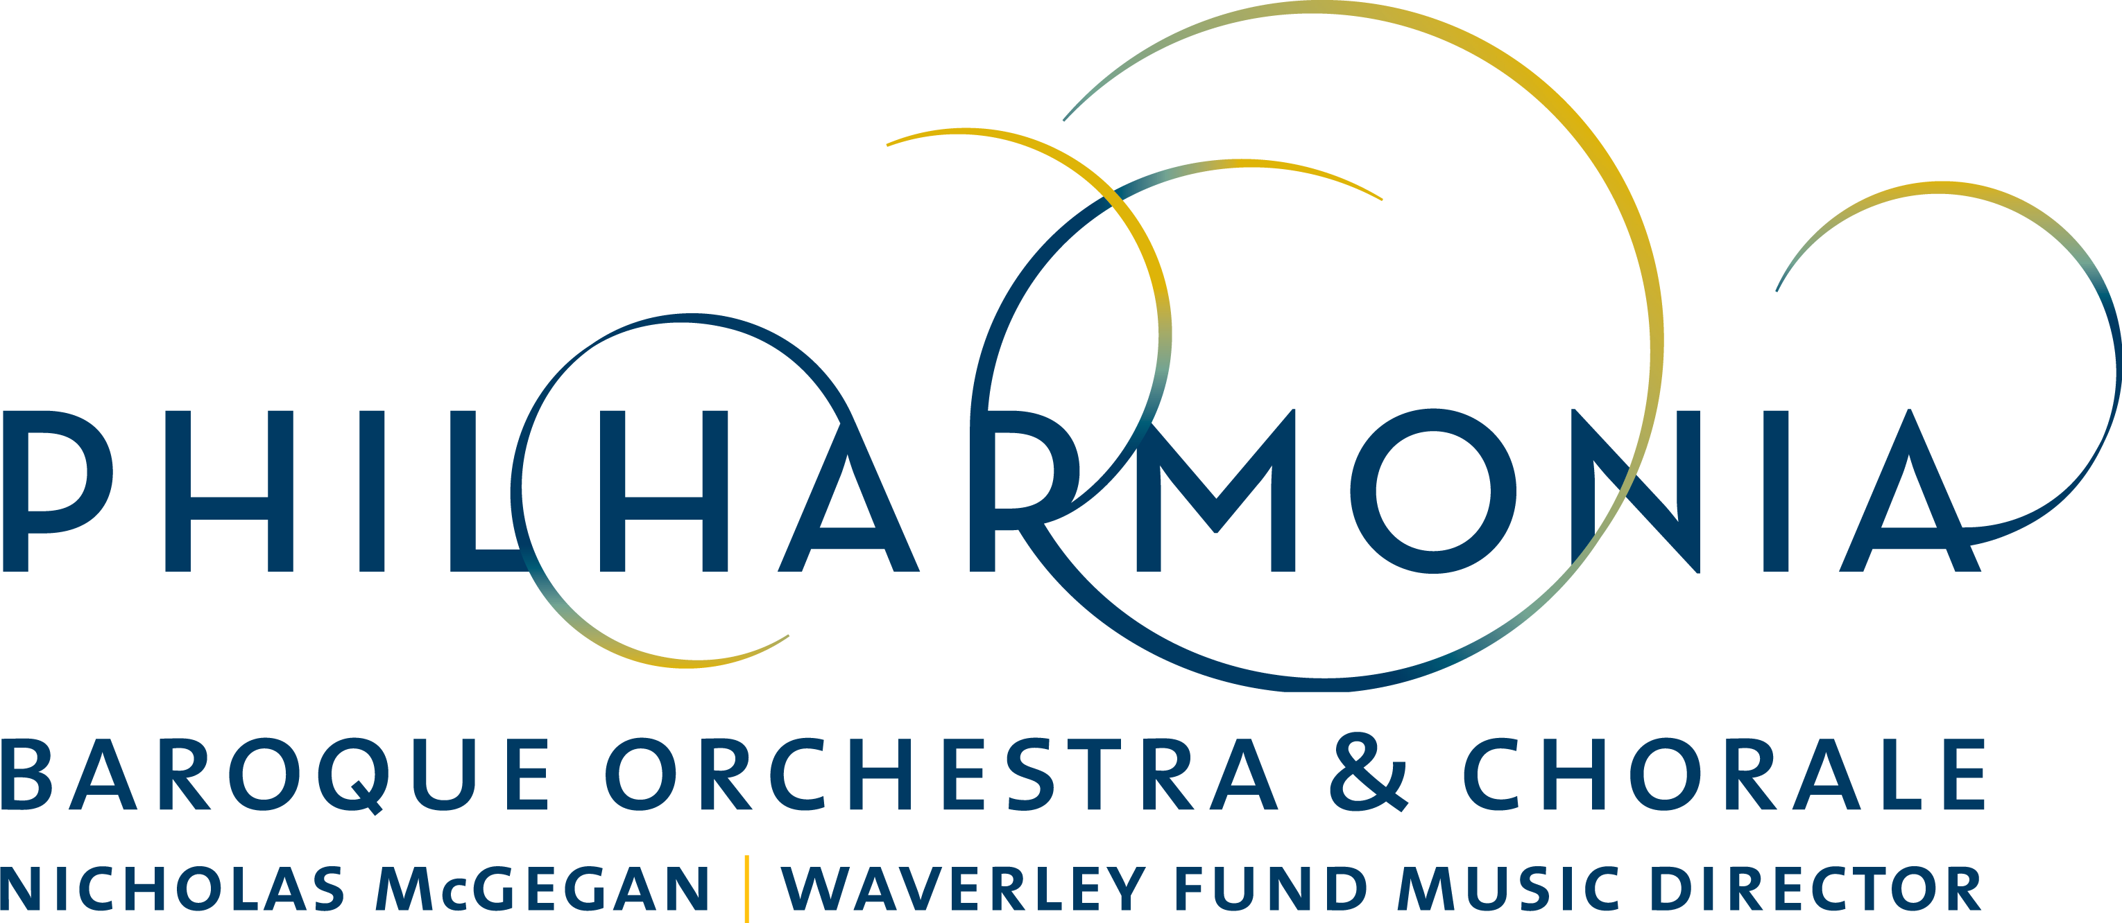

PRESS RELEASE

FOR IMMEDIATE RELEASE

PBO Performs Back-to-Back Handel Oratorios in December with “Messiah” and “Joseph and his Brethren”

CONTACT:
Dianne Provenzano
Marketing & Communications Director
press@philharmonia.org
(415) 252-1288 x 315

SAN FRANCISCO - BERKELEY - PALO ALTO

October 30, San Francisco–From standard repertoire to rare gems, no one interprets George Frideric Handel like conductor Nicholas McGegan and Philharmonia Baroque Orchestra and Chorale, who will perform back-to-back Handel programs in December. First will be PBO’s critically-acclaimed, historically-informed performance of Handel’s “Messiah” in concerts December 8–10 followed by the rarely performed “Joseph and his Brethren” with concerts December 14–17.

Nicholas McGegan has brought both the classic and rare works of Handel to audiences around the globe for over five decades, and has helped spread early music well beyond the period-instrument world. As Artistic Director and Conductor at the Göttingen Handel Festival for 20 years, McGegan presented nearly twenty Handel operas. As a recording artist, McGegan has explored the depths of the composer’s output, with over 50 recordings of Handel works, including a dozen oratorios and twenty of his operas. His world premiere recording with PBO of “Susanna” received a GRAMMY® nomination for Best Choral Performance. In summer of 2017, McGegan conducted the Royal Northern Sinfonia for the BBC Proms in Hull, marking 300 years since Handel’s “Water Music” was first famously performed on the River Thames.

McGegan and Philharmonia Baroque Orchestra and Chorale will inspire audiences with Handel’s holiday treasure “Messiah” at Herbst Theatre on Friday, December 8 at 7 pm; on Saturday, December 9 at 7 pm at First Congregational Church in Berkeley; and Sunday, December 10 at 3 pm at Weill Hall, Green Music Center in Rohnert Park. The Orchestra and Chorale will be joined by soprano Yulia Van Doren, mezzo-soprano Diana Moore, tenor James Reese and baritone Philip Cutlip. There will be a pre-concert talk given by Philharmonia Chorale Director Bruce Lamott forty-five minutes prior to each performance that will be open to all ticket-holders. Hear this classic Handel work like never before on period instruments for which the piece was written.

McGegan is also excited to present Handel’s “Joseph and his Brethren”, never performed before by PBO and featuring mezzo-soprano Diana Moore in a trouser role as the title character with soprano Sherezade Panthaki, tenor Nicholas Phan and baritone Philip Cutlip. Soprano Gabrielle Haigh and mezzo-soprano Abigail Levis will also be featured, as will the Philharmonia Chorale who will perform the roles of Joseph’s Brethren, Egyptians and Hebrews.

PBO Chorale Director Bruce Lamott says, “It's hard to find a Handel oratorio that has escaped our attention during the past 37 years, but we are performing “Joseph and his Brethren” for the very first time, and quite possibly the first time it has been seen in the Bay Area. Nic McGegan's definitive interpretation will highlight the poignancy and power of this musical saga in what may be a once-in-a-lifetime listening experience.”

Because of its rarity, McGegan and PBO have decided to record Handel’s “Joseph and his Brethren.” But unlike PBO’s other live recordings, McGegan will take the Orchestra, Chorale and guest artists into the studio at Skywalker Sound in Marin for a three-day, high-tech recording session after the concert set. This will be Philharmonia Baroque Productions’ eleventh recording for digital and CD release during the winter of 2018.

McGegan leads PBO in “Joseph and his Brethren” on Thursday, December 14 at 7 pm at Herbst Theatre in San Francisco; on Friday, December 15 at 7:30 pm at First United Methodist Church in Palo Alto; and on Saturday, December 16 at 7 pm and Sunday, December 17 at 4 pm at First Congregational Church in Berkeley. There will be a pre-concert talk given by Philharmonia Chorale Director Bruce Lamott forty-five minutes prior to each performance that will be open to all ticket-holders.

Tickets range from $28 to $125. For more information about these and other Philharmonia Baroque Orchestra & Chorale concerts, visit philharmonia.org. For tickets, visit cityboxoffice.com or call 415-392-4400.

Classical KDFC is the radio home of Philharmonia Baroque Orchestra & Chorale. KDFC broadcasts an unreleased live Philharmonia concert recording the second Sunday of every month from 8-9 PM.

CALENDAR DETAILS

PROGRAM 1: Handel’s “Messiah”

WHO:
Nicholas McGegan, conductor
Philharmonia Baroque Orchestra & Chorale

WHAT: Concert Performance
Handel’s “Messiah”

FEATURED ARTISTS:
Yulia Van Doren, soprano
Diana Moore, mezzo-soprano
James Reese, tenor
Philip Cutlip, baritone
Philharmonia Chorale,
Bruce Lamott, director

TICKETS: $28-$125
Available at City Box Office 415-392-4400 or cityboxoffice.com

WHEN/WHERE:

Friday, December 8, 7 pm
Herbst Theatre, San Francisco

Saturday December 9, 7 pm
First Congregational Church, Berkeley

TICKETS: $50-$110
Available at Green Music Center 866-955-6040 or gmc.sonoma.edu

WHEN/WHERE:

Sunday, December 10, 3 pm
Weill Hall, Green Music Center, Rohnert Park

PROGRAM 2: Handel’s “Joseph and his Brethren”

WHO:
Nicholas McGegan, conductor
Philharmonia Baroque Orchestra & Chorale

WHAT: Concert Performance
Handel’s “Joseph and his Brethren”

FEATURED ARTISTS:
Sherezade Panthaki, soprano
Diana Moore, mezzo-soprano
Nicholas Phan, tenor
Philip Cutlip, baritone
Gabrielle Haigh, soprano
Abigail Levis, mezzo-soprano
Philharmonia Chorale,
Bruce Lamott, director

TICKETS: $28-$125
Available at City Box Office 415-392-4400 or cityboxoffice.com

WHEN/WHERE:

Thursday, December 14, 7 pm
Herbst Theatre, San Francisco

Friday, December 15, 7:30 pm
First United Methodist Church, Palo Alto

Saturday, December 16, 7 pm
First Congregational Church, Berkeley

Sunday, December 17, 4 pm
First Congregational Church, Berkeley

