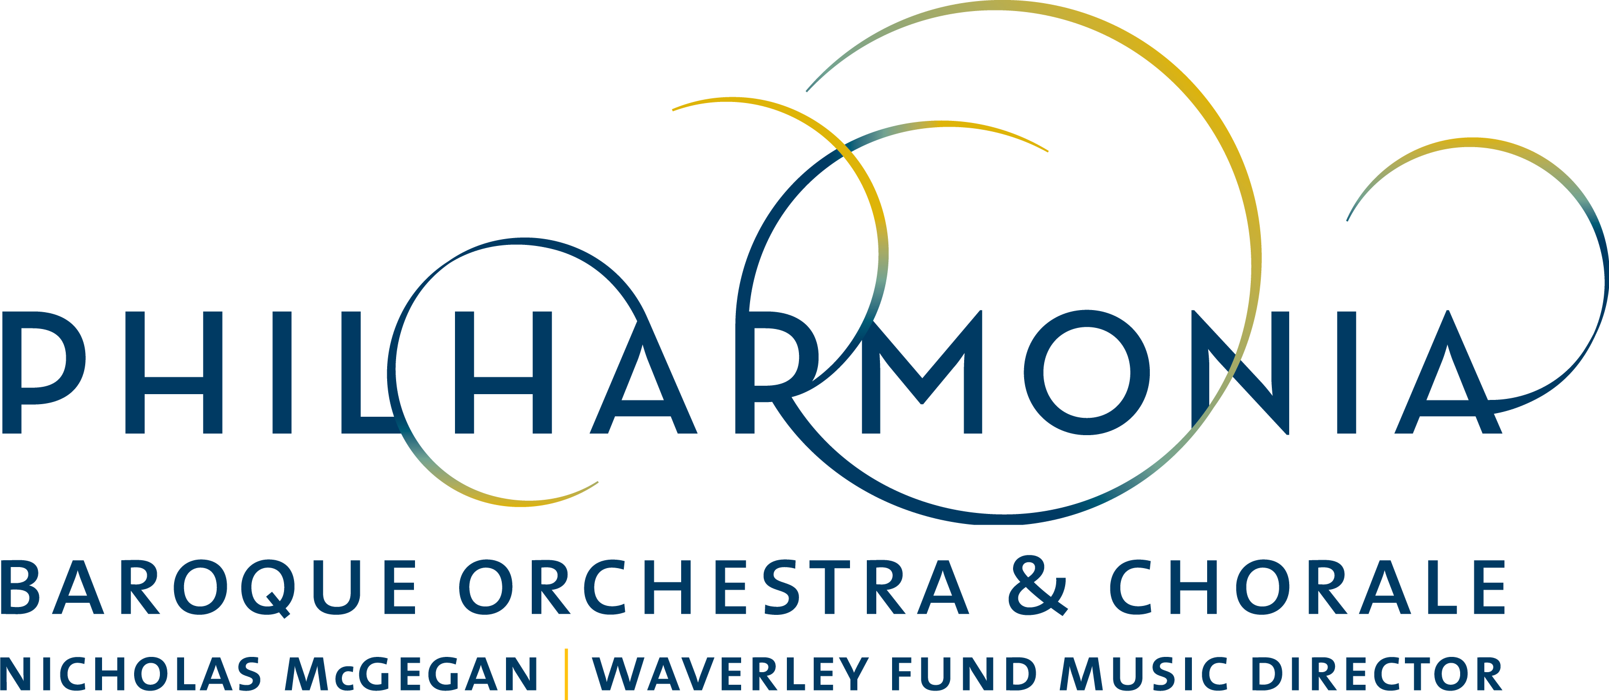

PRESS RELEASE

FOR IMMEDIATE RELEASE

PBO Violinist Elizabeth Blumenstock Leads a Program of Baroque Venetian Violin Treasures November 8-12

CONTACT:
Dianne Provenzano
Marketing & Communications Director
press@philharmonia.org
(415) 252-1288 x 315

SAN FRANCISCO - BERKELEY - PALO ALTO

September 22, 2017, San Francisco–Philharmonia Baroque Orchestra & Chorale will present a vivacious program of violin works from–and inspired by–Baroque Venice this November. PBO’s long-time co-concertmaster and violinist Elizabeth Blumenstock will lead the Orchestra in a program called “Vivaldi in Venice” that she designed to spotlight the virtuosity of her fellow Orchestra members.

Baroque era Venice was the hub of violin-making and the city’s musicians and composers wrote a profusion of music at the time. Some of that work is rarely performed today—the program includes a violin concerto by one of Blumenstock’s favorite composers, Giuseppe Tartini, whom she has helped champion in the last decade. Blumenstock will open with Vivaldi’s masterpiece “l’Autunno” (Autumn) from “Le Quattro Stagioni” (The Four Seasons) and will also showcase works by Locatelli, Veracini, Campra, Pisendel, and Handel. In addition, oboist Marc Schachman will perform the virtuosic Albinoni Concerto in D minor.

In addition to serving as co-concertmaster, soloist and leader at PBO, Blumenstock is artistic director of the Corona del Mar Baroque Music Festival and concertmaster of the International Handel Festival in Göttingen, Germany. An enthusiastic teacher, Blumenstock teaches at the San Francisco Conservatory of Music and Juilliard for their Historical Performance program. When performing with PBO, she plays a 1660 Andrea Guarneri violin on loan from the Philharmonia Baroque Orchestra Period Instrument Trust. The instrument is ideally suited for this quintessentially Baroque program.

Blumenstock herself will present the preconcert talk 45 minutes prior to each of four concerts that will take place throughout the Bay Area. See “Vivaldi in Venice” with Elizabeth Blumenstock Wednesday, November 8 at 7:30 pm at First United Methodist Church in Palo Alto; Friday, November 10 at 8 pm at Herbst Theatre in San Francisco; Saturday, November 11 at 8 pm at First Congregational Church in Berkeley; and Sunday, November 12 at 4 pm at First Congregational Church in Berkeley.

Tickets range from $28 to $120. For more information about this and other Philharmonia Baroque Orchestra & Chorale concerts, visit philharmonia.org. For tickets, visit cityboxoffice.com or call 415-392-4400.

Classical KDFC is the radio home of Philharmonia Baroque Orchestra & Chorale. KDFC broadcasts an unreleased live Philharmonia concert recording the second Sunday of every month from 8-9 PM.

CALENDAR DETAILS

WHO:
Elizabeth Blumenstock, leader/violin
Philharmonia Baroque Orchestra & Chorale (Chorale not performing)

PHOTOGRAPHY: (Click to download)

Elizabeth Blumenstock

WHAT: Concert Performance
Vivaldi in Venice with Ellizabeth Blumenstock

VIVALDI “l’Autunno” in F major, RV 293 from Le quattro stagioni
LOCATELLI Introduzione Teatrale Op. 4, No. 5 in D major
PISENDEL Concerto for Violin and Two Oboes in G minor
VERACINI Sarabande “Appoggiato” from Overture No. 4 in F major​
HANDEL Overture to Agrippina in G minor, HWV 6
ALBINONI Concerto for Oboe in D minor, Op. 9, No. 2
TARTINI Concerto for Violin in A major, D. 91
CAMPRA Le Carnaval de Venice (selections)

PRICE: Range from $28 to $20

TICKETS: Available at City Box Office 415-392-4400 or cityboxoffice.com

WHEN/WHERE:

Wednesday November 8, 7:30 pm
First United Methodist Church, Palo Alto

Friday November 10, 8 pm
Herbst Theatre, San Francisco

Saturday November 11, 8 pm
First Congregational Church, Berkeley

Sunday November 12, 4 pm
First Congregational Church, Berkeley

SHORT DESCRIPTION

Philharmonia Baroque Orchestra & Chorale violin legend Elizabeth Blumenstock returns to lead a vivacious program, postmarked Venice—music by Venetians and by those who visited this hub of Baroque violin music. Hear Blumenstock’s 1660 Guarneri sing in a program she designed to spotlight our virtuosic players. Oboist Marc Schachman will shine in the D minor oboe concerto by Albinoni after Blumenstock evokes the harvest and the hunt in Vivaldi’s beloved “Autumn” from “The Four Seasons.” Programs throughout the Bay Area November 8-12, 2017.

###

